CHAPTER 2
PROBLEM DEFINITION
2.1 Problem Description
Currently, there are two main ways of mobile devices connection: client-server based and non-Internet based (e.g. Bluetooth, Wi-Fi Direct). For the client-server based network in figure 2.1, the data is stored on the central server. Each client can push data to the central server, and also send request to the server to retrieve data they are interested. In this centralized network, each node must have Internet connection. For the non-Internet based network in figure 2.2, it provides communication possibility when there is no Internet available. Each device communicates to others directly without the router. The data is stored locally on each device. The device in the network uses specific technology to push and retrieve data with others.
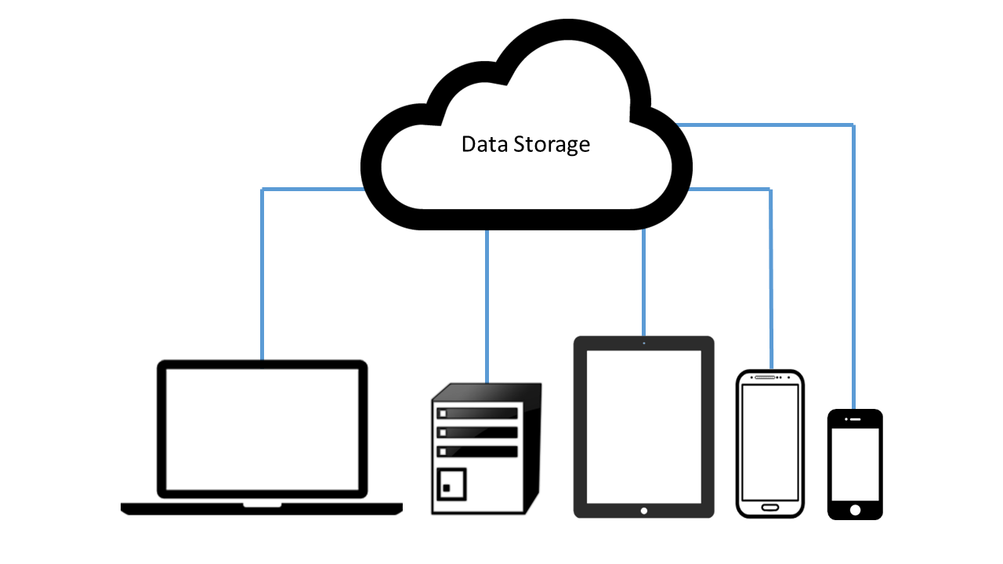
Figure 2.1 Device Connection in Cloud Based Network

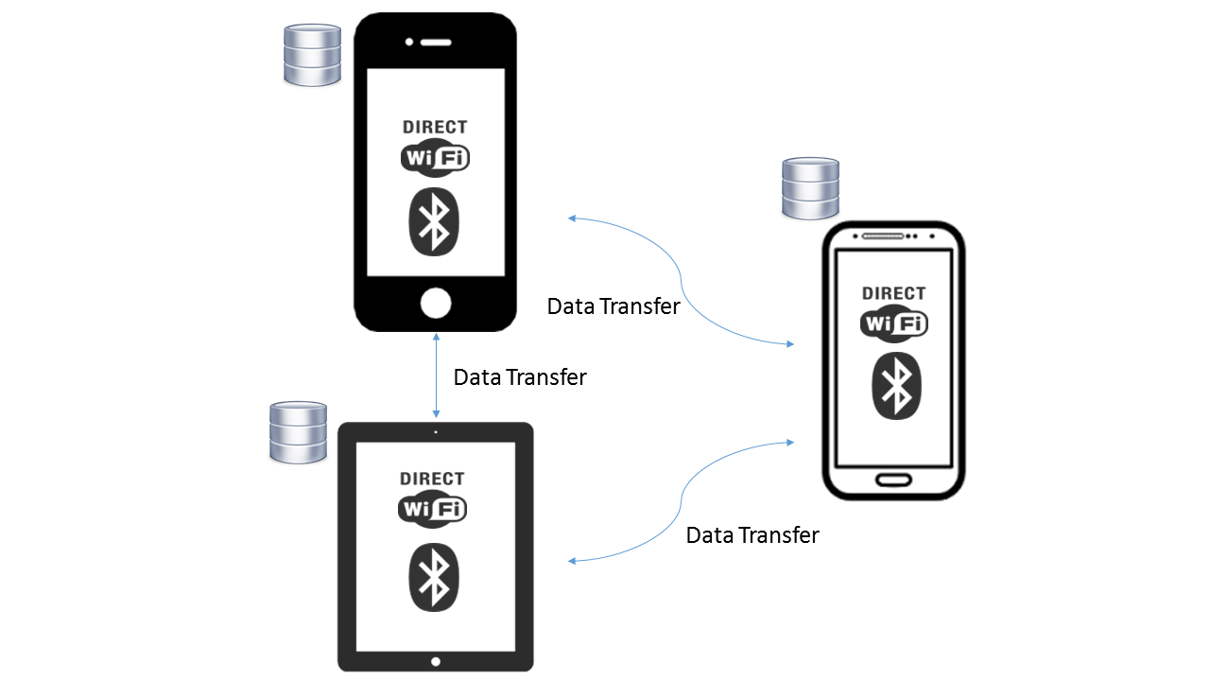

Figure 2.2 Multiple Connection in P2P Network

From individual aspect of view, most of people have more than one or two mobile devices like smart phone, tablets, smart watches etc. at home. On the other hand, for many organizations, they have tended to transfer their office mode from desktop to mobile side so that people can get access to the data anytime and anywhere. In this way, it can help the organizations improve their productivity. Nevertheless, since the data is transferred every day, it increases the chance of data lost and make the data management more difficult. It is hard to track where the data is and which device has accessed to these data. If there is something wrong with the data, or any leak of data, it is difficult for the user to find out the source of the problem. Moreover, as shown in figure 2.3, if one device is lost, most users have no idea what exactly is lost. It can be a big problem for both individuals and organizations.
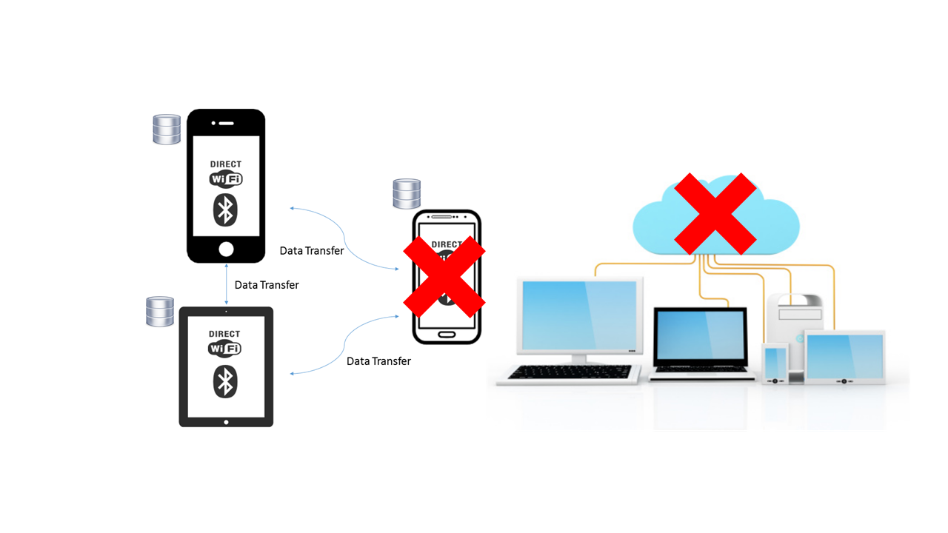
Figure 2.3 Device Disconnected from Network
2.2 Research Goal
For most of the data management systems, they focus on the situation when there is Internet access. If the Internet connection is lost or unstable, the data is hard to manage. Therefore, in this research, we will design and implement a new data distribute architecture to track and synchronize data among multiple mobile devices in Non-Internet environment. By tracking the data among mobile devices, we can reduce the risk of data lost, and also find out the source of problem when data is wrong. By synchronizing the data in these devices, the data consistency can be improved.
2.3 Research Challenge
In order to construct this new data distribute system, there are few challenges need to be solved.
- Challenge 1: Device connection protocol
In a non-Internet based network, one of our goal is to build a system which need device to communicate directly, the best possible way to achieve it is using mobile Peer-to-Peer technology. However, there are many mobile Peer-to-Peer protocols: Bluetooth, Wi-Fi direct etc. Each of them have their advantages and drawbacks. Which one is suited for the system may be hard to decide.
- Challenge 2: Various roles of a device in the network
Typically, there are two main roles of a device during data transaction: data generator (device who pushes the data, also called publisher) and data consumer (device who receives data, also called subscriber). A device can be a generator, a consumer, or both. For each of this roles, different functionalities (push new data, update data, listen to the updates etc.) need to be implemented.
- Challenge 3: Data consistency
The data may be modified in transaction, how we can ensure the data on each device is the most updated. A data synchronization mechanism needs to be designed.
- Challenge 4: Device connectivity
Devices in the network cannot be connected all the time. One or more devices may be disconnected from the network. In this period, the data may be modified. How to keep the disconnected device updated is another difficulty.

CHAPTER 3
LITERATURE REVIEW
The goal of this research is to overcome those challenges mentioned in chapter 2. In this chapter, I will review some related researches and technologies which can be referred.
  - Mobile Computing
In this section, the current main computing trends: mobile computing will be covered. “Mobile computing technology enables the mobile worker to create, access, process, store and communicate information without being constrained to a single location.”[Challenging Issues and Limitations of Mobile Computing]. The goal of mobile computing is to provide a medium between people and information without spatial and temporal constraints. There are some features of mobile computing mentioned in [Research on Mobile Cloud Computing: Review, Trend and Perspectives]:
- Mobility
Each mobile node can easily connect to others in wired or wireless network during their movement.
- Diversity of network conditions
The mobile device can exist in various kinds of networks, such as wired network with high bandwidth, wireless personal area network, wireless local area network, and wireless wide area network. Some details about these networks will be covered in the later sections.
- Frequent disconnection and consistency
Due to the limitation of batter power, network conditions, the mobile device cannot connect to others all the time. However, they can reconnect and remain consistent with the network by following a specific protocol.

- Low reliability
As the signal is easy to interference, a mobile computing network has to address the security issue from the terminals, database, and application development.
According to [Challenging Issues and Limitations of Mobile Computing], the author mentioned three main concepts of mobile computing.
- Hardware
Mobile hardware contains two main categories: mobile devices or device components [http://www.tutorialspoint.com/mobile_computing/mobile_computing_overview.htm]. The mobile devices are normally defined as handheld computer such as smartphones, tablets, PDAs and so on. The device components are “defined by the size and form factor, weight, microprocessor, primary storage, secondary storage, screen size and type, means of input, means of output, battery.”[Challenging Issues].
- Software
Mobile software is a computer system or application designed to run on handheld computers. The common operation system running on mobile devices includes Apple IOS, Android, Nokia Symbian, Windows etc. The operation system is the essential software component required to operate mobile devices. Additionally, there are variety of mobile applications run on mobile devices to provide different functionalities. According to [Mobile web Apps vs. Mobile Native Apps: How to Make the right choice], there are two formats of mobile applications: native apps and web apps.
- Native Apps
A native app is programmed and designed for a specific operating system. The user downloads an app from a web store and installed on the device. The most common stores on the market are Apple Store and Google Play. There are two main advantages of native app: 1) Powerful user experience. Because the native app is downloaded from the app store, it can leverage the specific hardware (GPS, camera, Bluetooth etc.) and software (picture gallery, contact list etc.). 2) Ability to run offline. The native app remains installed on the device. There is no Internet requirement in order to launch the app. The user can pause/resume the app anytime. On the other, there are also some drawbacks of the native app, the biggest problem is Incompatibility for multiple platforms. As mentioned above, there are many mobile operation systems available. Each platform has its own language and tool to build app as shown in figure 3.1. In order to meet all the needs, more work and more money are required. [Mobile web Apps vs. Mobile Native Apps: How to Make the right choice]
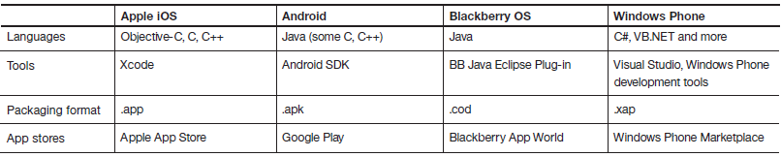
Figure 3.1 Multiple Mobile Platforms [Native, web or hybrid mobile-app development]

- Web Apps
A web app is a web based application formatted for various smartphones and tablets. The common way to access the web app is via the device’s web browser. There are three main technologies used for a web app development: HTML, CSS, and JavaScript. Due to the web apps are developed based on web browser, they are independent from different platforms. However, a normal web app needs to be downloaded from a web server each time its run. [Mobile web Apps vs. Mobile Native Apps: How to Make the right choice]
- Communication
“The ability of a mobile computer to communicate in some fashion with a fixed information system is a defining characteristic of mobile computing.” The type of mobile application is determined by the type and availability of communication media. [Challenging Issues and Limitations of Mobile Computing]. The authors in [Challenging Issues and Limitations of Mobile Computing] divided mobile device communication into four categories:
- Connected
The connected status implies a continuously high-speed connection between a mobile device and an information system (e.g. server) for data transfer.
- Weakly connected
In this situation, the mobile device and the information system communicate continuously with low speed.
- Batch
The mobile device is not continuously connected to the information system. The connection is established randomly to exchange data.
- Disconnected
Under this mode, the mobile device is incapable of communicating with the information system. The user can only access the local storage to retrieve data.

To sum up, mobile computing has brought about a life style in which mobile devices are essential part. Although it has many advantages comparing to the traditional PCs such as mobility and flexibility, the constraints also need to be considered while designing mobile-friendly architecture [Data synchronization in a network-volatile mobile ecosystem]:
- Limited Resource
Generally, mobile devices have less computation performance, storage capacity, and battery power comparing to PCs.
- Network Bandwidth
As mobile devices have higher mobility, it is easier to cause poor or none signal condition which result in low bandwidth.
- Intermittent Connectivity
In mobile computing, the unremitted connection is extremely difficult by reason of unreliable network connection.
These constraints are the core problems which can affect application performance. All of these need to be thought over in a good designed architecture.

  - Computer and Mobile Network
Computer networks are used to allow computers to exchange information among themselves. Each device in the network is direct or indirect connected together with a specific communication technology. The most common computer network is the Internet. In this section, I will review some network terminologies and the different types of network.
Based on different functionalities, there are several various types of networks. The two common classification standard are based on the size and the architecture of the network. According to [Computer networking: principle, protocols and practice], the authors addressed two most important architectures: the client-server and the peer-to-peer models. In [Data Communication and Computer Network], the network can also be distinguished based on their geographical span. Basically, there are four main categories: Personal Area Network (PAN), Local Area Network (LAN), Metropolitan Area Network (MAN), and Wide Area Network (WAN). More details are covered in the following sections.
    - Architecture Classification
- Client-Server Model
The client-server model is the most common network model. In this kind of network, each computer is either a client or a server. Normally, servers are powerful computers or processes which are used to manage files, database, or network traffic. Clients are PCs or mobile devices on which users can run applications [Comparison of centralized (client-server) and decentralized (peer-to-peer) networking]. In this model, the client (service requesters) send requests to the server (resource provider), then the server performs actions and returns the corresponding responses as shown in figure 3.2. In order to ensure the server and the client both understand the messages send from each other, they much follow the specific protocols [network protocols handbook].

Figure 3.2 Client-Server Network Model [Computer networking: principle, protocols and practice]
- Peer-to-Peer Model
In [A Survey of peer-to-peer content distribution technologies], the authors defined peer-to-peer network as following:
Peer-to-peer systems are distributed systems consisting of interconnected nodes able to self-organize into network topologies with the purpose of sharing resources such as content, CPU cycles, storage and bandwidth, capable of adapting to failures and accommodating transient populations of nodes while maintaining acceptable connectivity and performance, without requiring the intermediating or support of a global centralized server or authority.
This definition encompass two different peer-to-peer architectures based on the degree of centralization: completely decentralized system, hybrid decentralized architecture. In the completely decentralized peer-to-peer architecture, which is also called pure peer-to-peer, each peer is an equal participant in the network. There is no administrative roles. As shown in figure 3.3, no central server is required to manage and coordinate the connections. Each node has to self-organize themselves to communicate with other nodes. [Comparison of centralized and decentralized networking]
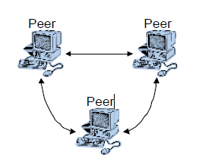
Figure 3.3 Pure Peer-to-Peer Architecture [Comparison of centralized (client-server) and decentralized (peer-to-peer) networking]
In the hybrid decentralized peer-to-peer architecture, it incorporates some features of the client-server model as shown in figure 3.4. Some of the nodes in the network are assigned a more important role: acting as local central server for facilitating the interaction between peers. [A survey of content distribution technologies]
Figure 3.4 Hybrid Decentralized Peer-to-Peer Architecture [A survey of content distribution technologies]
Each client in the network stores data locally that can be shared with the rest of the peers. All clients connect to a central server which contains two pieces of information [A survey of content distribution technologies]:
- Registered user connection information (IP address, time of connection etc.).
- A database table which lists the data that each client holds in the network.
A new peer contacts to the central server and provides the data information to it in order to join the group.
For searching and sharing the data, a peer send a request to the server. The server searches through the database, and return a list of users that hold the matching information. The peer then establishes a direct connection with the specific nodes. [A survey of content distribution technologies]
The advantage of this hybrid decentralized architecture is that it is easy to implement and it can search and locate data efficiently. On the other hand, the main disadvantage is the scalability since there are limitations to the size of the server database and its capacity to respond to the requests. Moreover, since the whole network is connected to the local server, if the master peer abandon the system, then the services will not be available to anyone. [A survey of content distribution technologies][Comparison of centralized (client-server) and decentralized (peer-to-peer) networking]
    - Size Classification
- Personal Area Network (PAN)
A Personal Are Network is the smallest network which is designed to satisfy personal needs. It includes Bluetooth or Wi-Fi enabled devices such as smart phones, tablets, and wireless printers etc.
- Local Area Network (LAN)
As defined in [data communication computer network tutorial] and [Introducing basic network concepts], a network that is contained in a relatively small area like school or single building is generally termed as a LAN, as shown in Figure 3.5. Normally, this type of network is easy and inexpensive to install. It provides a useful and efficient way of sharing the resources among the end users; meanwhile, it works under its own local domain and does not involve any heavy routing. In some LANs, they may contain local servers for file storage and locally shared applications.

Figure 3.5 Local Area Network Coverage [data communication computer network tutorial]
- Metropolitan Area Network (MAN)
The MAN is more like an expansion of a LAN. It generally spans throughout a metropolitan city. It can be in a form of Ethernet, cable TV, or ATM. Much of the technology like fast network components as well as the connection equipment used in LANs can also be used in MANs with more requirement. By applying the ISPs (Internet Service Provider) [duties for internet service provider] in the MAN, the users can expand their LAN to greater ones as shown in Figure 3.6. [Data communication computer network tutorial][Introducing basic network concepts]
Figure 3.6 Metropolitan Area Network [data communication computer network tutorial]
- Wide Area Network (WAN)
When the network expand beyond the range of the typical MAN, a larger area of network is introduced: Wide Area Network as shown in Figure 3.7. Normally, a WAN provides connection among MANs and LANs.

Figure 3.7 Wide Area Network [data communication computer network tutorial]

    - Summary
To sum up, by classifying networks according to different component roles, Client-Server based and Peer-to-Peer based models were covered. In Client-Server model, each device only has one role: either client or server. It offers centralized control which can cause the whole system suffer heavy delay or completely break down when the server is offline. In Peer-to-Peer model, two types were discussed: completely decentralized system and hybrid decentralized architecture. In the completely P2P system, each node is equal in the network. There is no master node. On the other hand, in hybrid decentralized network, some features of client-server model are encompassed.
Moreover, by classifying networks based on their geography, four categories were included: PAN, LAN, MAN, and WAN. PAN and LAN present small networks which only cover up to a floor or a building. PAN is designed for a single person purpose of usage, and LAN is desired by an organization or a company. Additionally, MAN and WAN refer to the larger network often cover a city or even a whole country. The Internet is one example of WAN.
In this research, the goal is to ensure the data tracking and synchronization in Non-Internet environment; therefore, which network architecture to be designed is critical. The combination of Peer-to-Peer model and Personal Area Network can satisfy the need.

  - Short-Range Mobile Peer-to-Peer Technology
In [Peer to Peer Network for Mobile Communication], “The peer-to-peer networking has shifted focus away from the static architectures of client-server model that characterised the early Internet, towards more, dynamic, mobile networks.” Mobile Peer-to-Peer technology is an essential part of mobile communication. Most people use mobile to share information via the Internet when they are apart. The signal is sent to the cell tower before a connection is made. However, this type of communication is a waste of resources if they are in a short distance. Therefore, the short-range mobile peer-to-peer technology is brought up. The two main technologies that have been used widely are Bluetooth and Wi-Fi Direct.
    - Bluetooth
“Bluetooth is the connection technology which can be used as link to share data among devices within a Personal Area Network (PAN)” [Voice over IP via Bluetooth/Wi-Fi Peer to Peer]. It is a ubiquitous, low energy wireless link which is available in most of mobile devices and tablet computers. The first version of Bluetooth was invented by telecom vendor Ericsson in 1994. Overall, there are four versions since the Bluetooth was developed. The two most prevalent implementations are Bluetooth Basic Rate/Enhanced Data Rate (BR/EDR) as version 2.0/2.1 which is known as Classic Bluetooth and Bluetooth with Low Energy (LE) as version 4.x. Each of this two versions has different use cases.
- Characteristics
The BR/EDR or Classic Bluetooth is usually used when the user needs to setup a relatively short-rage and continuous connection. The key feature of this mode is the pairing procedure. It requires user interaction to make a simple passkey. On the other hand, the Bluetooth Low Energy was originally built for the Internet of Things (IoT) [http://www.cisco.com/c/en/us/solutions/internet-of-things/overview.html?] which requires low energy consumption and instant connection setup. The main advantages of this mode are: 1) Multiple-vendor interoperability. 2) Ultra-low power consumption which enables the devices to run for months with standard coin-cell batteries. 3) Standard application development architecture which can reduce operational costs [Bluetooth SIG]. Moreover, in most of Bluetooth Low Energy devices, there are two modes implemented: single mode and dual mode. In single mode, only the low energy protocol stack is included. In dual mode, it includes Classic Bluetooth, Bluetooth High Speed (Bluetooth 3.x), and Bluetooth Low Energy protocols so that the Bluetooth enabled devices can access any versions of Bluetooth devices. For most new generations of mobile devices, they are all embedded with Bluetooth 4.x chips.
- Cover Range
As the Bluetooth uses radio transmissions for data exchange, the range is determined by the transmission power levels. Table 3-1 summarizes their range differences based on the various power levels.
Table 3-1 The Bluetooth Power Class [Bluetooth for Programmers]
Power Class | Transmission Power Level | Advertised Range
1 | 100 mW | 100 meters
2 | 2.5 mW | 10 meters
3 | <1 mW | < 1 meters

For most of the Bluetooth-enabled devices such as cell phones, tablets, and laptops are class 2 devices. If there is a connection setup between different classes, the range is limited by the less power level. [Bluetooth for Programmers]
- Topology
In Bluetooth network, the physical channel that connects two or more devices called piconet. In a piconet, the device which scans for other device is called “slave”, and the advertising device is called “master”. Each piconet consists of one master and up to seven slaves. Any Bluetooth device can function as master or slave. While Bluetooth devices are connected, they communicate on the same physical channel by synchronizing with the common clock and hopping sequence. The common clock is identical to the master’s Bluetooth clock, and the hopping sequence is generated from the Bluetooth clock and the master’s Bluetooth address [Specification of Bluetooth 4.0].
One Bluetooth device can participate to two or more piconets simultaneously which needs to do on a time-division multiplexing basis [Adaptive Scatternet Support for Bluetooth using Sniff Mode]. However, a device can never be the master of more than one piconet as the piconet is defined by the master’s Bluetooth clock. For the Bluetooth device that is the member of two or more piconets is said to be connected in a scatternet as shown in Figure 3.8 and Figure 3.9 which are topologies of Bluetooth BR/EDR and Bluetooth Low Energy respectively [Forming Scatternets from Bluetooth Personal Area Networks], [Specification of Bluetooth 4.0].
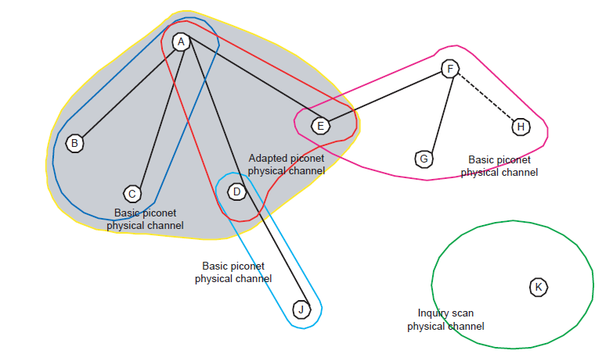
Figure 3.8 Bluetooth BR/EDR Topology [Specification of Bluetooth 4.0]

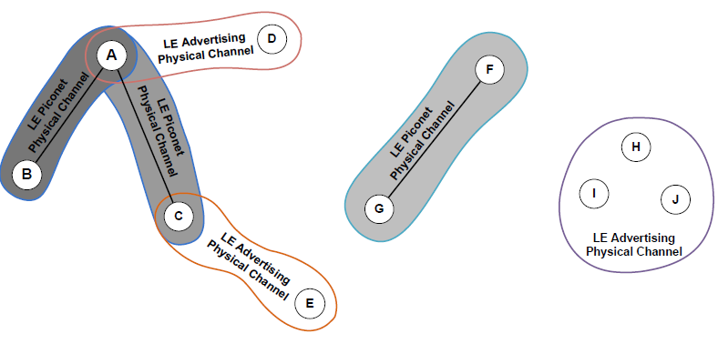
Figure 3.9 Bluetooth Low Energy Topology [Specification of Bluetooth 4.0]
In Figure 3.8, it shows an example topology of Classic Bluetooth. Device A is a master device in a piconet, which is the shaded area, with device B, C, D, and E as slaves. Meanwhile, there are two more piconets: one piconet with device F as the master and device E, G, H as slaves, and the other piconet with device D as master and device J as slave to it. In piconet A, there are two physical channels. B and C use basic channel to communicate with A as they are only involved in one piconet. D and E are using adapted physical channel as this kind of channel allows them to spare some radio frequencies for different piconets.
In Figure 3.9, it demonstrates the topology of Bluetooth Low Energy. Device A acts as a master in a piconet which has device B and C as slaves. The difference of these two topologies is the number of physical channels needed for different slaves. In Classic Bluetooth, each slave in one piconet communicate with the master on a common physical channel. On the other hand, in Bluetooth Low Energy, each slave connect to the master on a separate channel.

    - Wi-Fi Direct
Wi-Fi direct is also called Wi-Fi P2P which is defined and developed by Wi-Fi alliance. Normally, Wi-Fi is the most common way to access the Internet. However, as people’s demand increasing, the Wi-Fi technology needs evolve into a new stage; therefore, the Wi-Fi direct came out. It aims at enhancing device to device communications in Wi-Fi environment.
- Architecture
As mentioned in [device to device communications with Wi-Fi direct overview and experimentation], the typical Wi-Fi Local Area Network is created and broadcasted by Access Point (AP). Therefore, in this network, a device is clearly defined either as an AP or a client, and each of these roles have different set of functionalities. However, these roles in Wi-Fi Direct are defined dynamically, and a Wi-Fi Direct device has to implement the functionalities of both roles: client and AP. Meanwhile, these roles could also be executed simultaneously by the same device with different frequencies.
The networks formed by Wi-Fi Direct devices are known as P2P Groups. There are two main device roles in the group: P2P Group Owner (GO) act as an AP and P2P Clients. As mentioned above, these two roles are not static in the group; therefore, when these two devices discover each other, they need to negotiate to determine which one of them to be the GO. The details of the negotiation will be covered later. Once the group is established, other devices can join the group by connecting to the GO as connecting to the AP in traditional Wi-Fi network as shown in Figure 3.10[Wi-Fi p2p specification].
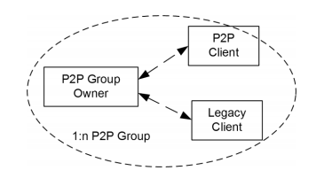
Figure 3.10 Wi-Fi Direct Topology [Wi-Fi p2p specification]

The default Wi-Fi Direct architecture for Android is designed for 1:N devices which means that the devices can only communicate within the same group [A demonstration for content delivery on Wi-Fi Direct Enabled devices]. However, the alternative architecture for inter-group communication has already be proposed in [Content-centric routing in Wi-Fi Direct multi-group networks].
In the group, the GO has to run a Dynamic Host Configuration Protocol (DHCP) server application in order to provide P2P Clients with IP addresses. Moreover, the P2P GO is the only device in the group that is allowed to cross-connect the P2P clients to an external network [Device to device communications with Wi-Fi direct: overview and experimentation].
- Group Formation
There are three main types of group formation in Wi-Fi Direct: standard, autonomous and persistent; and each of them has different stages as stated in Figure 3.11. Which types of formation is used depending on different situations, e.g. if the devices have been connected before, or if there is pre-shared security information available [device to device communications with Wi-Fi Direct overview].
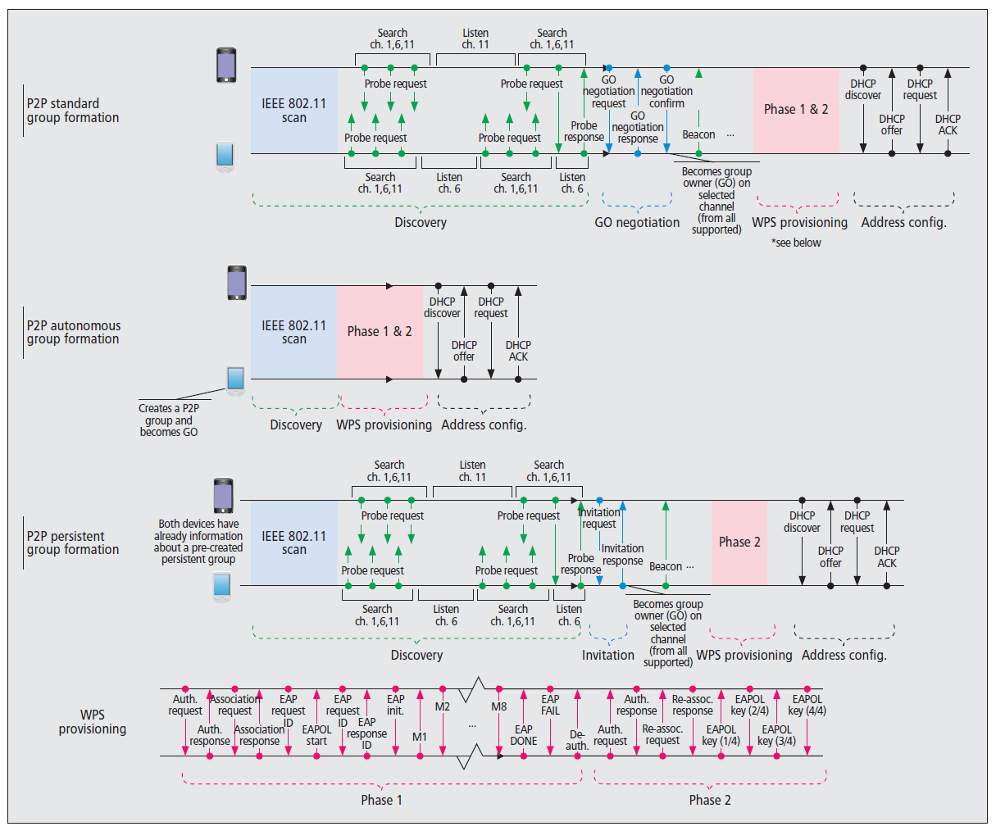
Figure 3.11 Different Wi-Fi P2P Group Formation Procedures [device to device]

Each of these types have different phases [Wi-Fi Direct whitepaper]:
- Discovery Device
Scan for existing P2P groups and Wi-Fi networks to establish connection
- Determination of GO
- Two devices negotiate for GO based on capabilities.
- One device is selected as GO at formation.
- Provisioning of the group
- Appropriate credentials are used for group establishment.
- Exchange credentials using Wi-Fi simple configuration.
More details about the security will be covered in the later section.
- Address Configuration
The GO provides IP address to a client in the group using DHCP.

In the standard case, all these four phases are included. At the beginning, the discovery phase is initialized. After the scan, a discovery algorithm is executed. A device selects one of the social channels, channel 1, 6 or 11, in the 2.4 GHz band as listen channel; then the device switch its status between two states: search state and listen state. In search state, the device scans other devices by sending Probe Requests in its social channels. In listen state, the device listens for the Probe Requests sent from other devices, and then response to it with Probe Responses. Once the two devices found each other, the GO negotiation phase is triggered. This is a three-way handshake process: Request/Response/Confirmation. In this step, the two devices agree on which one will act as GO [WFD White Paper]. “The primary purpose of Group Owner Negotiation is to exchange the Group Owner Intent attribute to communicate a measure of desire to be P2P Group Owner” [Wi-Fi Direct specification 1.5]. The device that declares the highest Intent value becomes the GO. Besides, if one device must be the GO, the Group Owner Intent attribute has to be set to 15 as demonstrate in Figure 3.12.

Figure 3.12 Group Owner Determination Flowchart [Wi-Fi Direct specification1.5]
In order to prevent the conflicts when two devices declare the same GO Intent value, a tie-breaker bit is included in the GO Negotiation Request. It is set randomly whenever the request is sent [WFD white paper].
In the autonomous group formation, a P2P device may be able to create a group autonomously, and it becomes the GO. As there is only one device participate when the group is forming, the search and GO Negotiation steps are omitted as shown in Figure 3.11. Other devices can discover the established group using traditional Wi-Fi scanning procedure, then proceed to the WPS Provisioning and Address Configuration phases. [Device to device]
The last group formation type is persistent. In this formation, P2P devices can establish a group as persistent by using a parameter in the P2P Capability attribute which contains multiple indicators [Wi-Fi specification 1.5]. In this status, the group stores network credentials which is assigned to GO and client for subsequent re-instantiations of the group. More specifically, if a device recognizes that it has formed a persistent group with the corresponding device before, then any of them can use the Invitation Procedure [Wi-Fi specification 1.5] to quickly re-connect. The demonstration is shown in Figure 3.11. The standard GO Negotiation is replaced by the invitation procedure. Moreover, the provision steps is reduced as the credentials can be reused. [Device to Device]
Despite which type the group formation is, each of them involves in the WPS. It is short for Wi-Fi Protected Setup [Wi-Fi protected setup technical specification] which is implemented to support secure connection with minimal user intervention. Generally, the WPS establishes a secure connection by generating a PIN in the client, or pressing a button in both GO and client devices. There are two parts in the operation of WPS. In the first part, the GO needs to generate and issue the network credential such as security keys to the client. It is presented as phase 1 of WPS Provisioning in Figure 3.11. In the second part, which is described as phase 2 in Figure 3.11, the client disassociates and reconnects with its new authentication credentials. By doing so, if these two devices forms group in the way of persistent group, it is not necessary to go through the first phase. [Device to device]
    - Comparison
As reviewed in the previous section, Bluetooth and Wi-Fi Direct are explained in details from the aspects of characteristic, architecture, and topology. Each of them have their own advantages and drawbacks. In this section, the comparison between these two technologies will be covered.
- Network Size
As mentioned above, the maximum number of devices for a Bluetooth piconet is eight (seven slaves and one master). It is possible to extend this number to 255 while each device does not participate in data exchange but only keep synchronization with the master’s transmissions. On the other hand, according to the Wi-Fi Alliance, a Wi-Fi Direct network can be one-to-one or one-to-many. The number is expected to be smaller than the traditional access points which is 2007 for a structured BSS (Basic Service Set [Wireless LAN Networking White Paper]). Connection to multiple devices is an additional feature. The size is depending on the device manufacture. [Performance analysis and comparison of wireless protocols standards] [Wi-Fi Alliance]
- Speed
Based on the information from [specification of Bluetooth 4.2], the data rate of Bluetooth Basic Rate is 1 Megabit per second (Mb/s) and the Enhanced Data Rate is 2 or 3 Mb/s. For Bluetooth 3.0 which is designed for high speed transfer, the speed can be up to 25 Mb/s. However, since the Bluetooth Low Energy is designed for use cases that require low data rate and has lower duty cycles, the speed for it is 1 Mb/s. On the other hand, the Wi-Fi Alliance mentioned on their website, Wi-Fi Direct supports typical Wi-Fi speed which can be as high as 250 Mb/s, but this speed depends on which protocols the devices follow e.g. 802.11 a, g, or n and also the physical environment of devices [Wi-Fi Alliance].
- Compatibility
As stated in 3.3.1, the Bluetooth Low Energy has single and dual modes. For single mode device, it is not backward compatible with Classic Bluetooth protocol. For dual mode implemented device, it is allowed to connect with both Classic Bluetooth and new Low Energy devices. For the Wi-Fi Direct device, it is not only compatible with the same certificated Wi-Fi Direct, it can also communicate with legacy Wi-Fi devices which are not implemented with Wi-Fi Direct.
    - Conclusion
Both of these two technologies have been widely used by electronic devices. In this research, we are focusing on designing an architecture which can track and synchronize mobile application data in Personal Area Network. It requires high scalability while there is new device joining the group, so the number of devices in the network can be variable. Moreover, the speed is also critical for this research as it requires high frequency of data transmission. Therefore, after consider these factors, the Wi-Fi Direct will be applied as the wireless technology.
  - Web Service
Web Service (WS) is a collection of protocols and that can be used to exchange data between applications over a network despite which programming languages the applications written in or the platforms the systems are running on [http://www.tutorialspoint.com/webservices/what_are_web_services.htm].
The basic architecture of WS is illustrated in Figure 3.13. There are four steps in the Web Service process [https://www.w3.org/TR/ws-arch/#id2260892]:
- The service provider and requester become known to each other. By known, it means these two components have the awareness of each other’s existence.
- These two entities agree on the service description and semantics that will manage the interaction between them. “The semantics of a web service is the shared expectation about the behavior of the service, in particular in response to messages that are sent to it”. The web service description is a specification of the web service interface. It defines the message formats, datatypes etc.
- The service description and semantics are input to the requester and the provider.
- These two entities exchange messages and data.
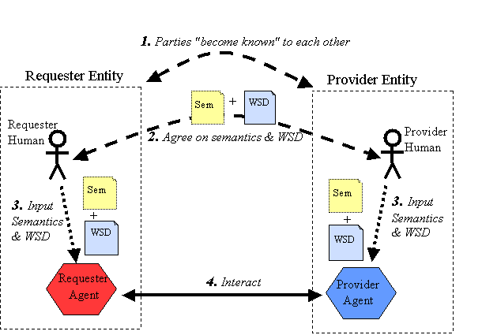
Figure 3.13 Web Service Architecture [https://www.w3.org/TR/ws-arch/#id2260892]
Generally, there are two main Web Services that are used broadly: the Representational State Transfer (RESTful) and the Simple Object Access Protocol (SOAP). In the following sections, these two services will be explained and compared from different aspects.
    - RESTful
RESTful stands for Representational State Transfer. It was first introduced by Roy Fielding in [Architectural Styles and The Design of Network-based Software Architectures] in 2000. It is normally, but not always, communicate over the HTTP protocol which is a stateless, client-server protocol. As stated in [http://rest.elkstein.org/], “despite being simple, REST is fully-featured; there’s basically nothing you can do in Web Services that can’t be done with a RESTful architecture”. The way RESTful works is demonstrated in Figure 3.14. The consumer send request to the provider which is usually the web server, then the server send back the response in XML.

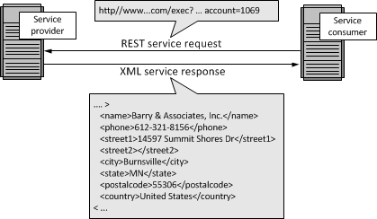
Figure 3.14 REST Message Exchange [Service Architecture]

In one paper of Cesare [RESTful Web Services vs. “Big” Web Services: Making the Right Architectural Decision], he mentioned that REST architecture is based on four principles:
- Resource identification through URI
Each resource can be referred by a unique universal resource identifier (URI) which provide a global addressing space for resources.
- Uniform interface
Resources use four main standard HTTP operations: PUT (create), GET (read), POST (update), DELETE (delete). Each of these operations have different functionalities. PUT creates new resource which can be deleted by DELETE or transferred to a new state by POST, and GET is for retrieving current stat of a resource.
- Self-descriptive message
In order to access the resource with more efficient way, REST decouples them from their representation to a variety of formats (HTML, XML, plain text, etc.).
- Stateful interaction through hyperlinks
Each interaction between the client and the resources is stateless, i.e., request messages send from the client are self-contained which means that no client context is stored on the server between requests. All the information needed to service the request is included in each request from the client.
The main strength of REST in [RESTful Web Services vs. “Big” Web Services: Making the Right Architectural Decision]:
- It has already been well-known by W3C/IETF and the infrastructure has become pervasive. Clients and servers based on HTTP protocol are widely available for all primary programming languages and operation systems. Additionally, the HTTP port 80 is commonly left usable in most firewall configurations.
- It is inexpensive to acquire because of its lightweight. The requirement needed to build an interaction using RESTful is very small as developers only need a traditional web browser to do tests instead of a well-developed software.
- Efficiency in processing messages. As the REST choices lightweight message formats such as JavaScript Object Notation (JSON) [http://www.json.org/fatfree.html], or plain text (for very simple data types), which can optimize the performance of a web service.
    - SOAP
SOAP is the abbreviation for Simple Object Access Protocol which is a protocol specification for exchanging information in the implementation of Web Service between the service consumer and provider over network. It uses XML as its message format. Normally, it is used over HTTP the same as the RESTful, but other protocols may also be used, i.e. Simple Mail Transfer Protocol (SMTP) [simple mail transfer protocol].
The SOAP message is consisted of four XML elements as shown in Figure 3.15. The top level element is called envelope which contains a header and a body. The envelope normally identifies the document as a SOAP message and also defines the message structure. The header in the envelope is an optional element to provide additional message-layer infrastructure information such as authentication, encoding data and Quality of Service (QoS) configuration. The body contains the payload of the message which can be defined using the Web Service Description Language (WSDL) [http://www.tutorialspoint.com/wsdl/wsdl_tutorial.pdf] specification. The last element is fault which carries a client or server error information. [RESTful Web Services vs. “Big” Web Services: Making the Right Architectural Decision][http://www.service-architecture.com/articles/web-services/soap.html]
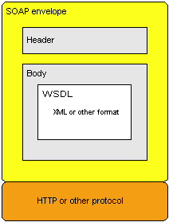
Figure 3.15 SOAP Message Elements [http://www.service-architecture.com/articles/web-services/soap.html]

Comparing to the REST, the SOAP also has some advantages points in [SOAP Web Services]:
- Protocol Transparency and independence. While using SOAP, the same message can be transported across different middleware systems via different protocols not only HTTP.
- Interoperability. SOAP has the ability to work between different platforms and operating systems. Therefore, the data can be retrieved from the legacy systems via SOAP as long as the data is encoded in XML or other readable format.

    - Conclusion
As stated above, each of SOAP and RESTful have their own strengths to meet different application needs. Nevertheless, in this research, the RESTful is more suitable as the communication technology between service consumer and provider. There are several factors are considered:
- Packet Size
As this research aims to design an architecture based on mobile environment which may have limited network bandwidth and CPU performance than PCs, the size of packet becomes an important element. According to the author mentioned in [SOAP web services], a SOAP message has many overhead because of the XML and the protocol design. Generating and parsing XML message is a time consuming task. This can consume a lot of bandwidth and the data transmission may lead to network latency. However, REST can decouple the resources to lightweight message formats such as JSON which is easier to parse compare to the XML.
- Cache
The goal of this architecture is to keep data tracking and synchronization in mobile devices; therefore, the temporary data storage is necessary to reduce the redundancy. In RESTful service, cache is well suited because the request is expressed in the URI. [https://www.captechconsulting.com/blogs/soap-vs-rest-for-mobile-services]
- Interoperability
Since the SOAP has been developed for a large number of different standards and versions. It is often that one vendor use a SOAP version which is slightly different from another vendor’s. It cause a problem when the cross platform application is developed. On the other hand, REST has the advantage as all developers need to use it is an HTTP stack. Due to most of the devices have it today, REST have better interoperability. [https://msdn.microsoft.com/en-us/magazine/dd942839.aspx]

  - Data Synchronization and Replication
As stated in [Review of Data Replication Techniques for Mobile Computing Environment]: “Data Replication in the computing terms means the mutual sharing of information so as to ensure consistency between redundant resources, such as software or hardware components, to improve reliability, fault-tolerance, or accessibility.” The major objectives of data replication are to ensure the data availability and reliability in case of a point failure [review of data replication techniques for mobile computing environment]. Copy multiple replicas to different sites and devices can improve the data access speed and reduce the communication cost as shown in Figure 3.16. Nevertheless, despite these benefits of replication, some extra operations are brought into the system; for instance, the data synchronization of various replicas on other devices. In this section, the different data replications techniques and three synchronization aspects (synchronization mechanisms, data storage patterns, and data transfer patterns) will be covered.

Figure 3.16 General Data Flow [Data Synchronization on Mobile Device]
    - Synchronization Mechanisms
The mechanisms of synchronization addresses the questions: “When should an application synchronize data between a device and a remote system (server)?” The developer must adopt different mechanism based on various constraints such as network condition, user interface design, device performance etc. Based on different needs of an application, there are two main types of synchronization [Data synchronization patterns in mobile application design]:
- Asynchronous Data Synchronization
The device synchronizes data asynchronously without affecting the user interface. The advantage of this pattern is having quick responsiveness. Without blocking the interface while the data is synchronized, the user doesn’t have to wait until the synchronization is finished as the application is still usable. However, it may also lead to the data inconsistencies. The data that is performing transactions can be the data that is exposed to the user interface. The user needs to refresh manually to retrieve the most updated data. [Data synchronization patterns in mobile application design]
- Synchronous Data Synchronization
In this mechanism, the device synchronizes data synchronously while the user interface is blocked. The strength of this mechanism is the data accuracy. The user can only access the data as soon as the synchronization is finished. It is appropriate for the application which relies on the response of an action from a remote server. On the other hand, the liability of this pattern is the user interface blocking. If the synchronization takes place on the same thread as the user interface, it can cause the block of network or database operation and the application may turn to be unresponsive. [Data synchronization patterns in mobile application design]
    - Data Storage Patterns
In this pattern, it address the questions: “How much data should be stored?” and “How much data should be available without further transfer of data?” Usually, the mobile devices have limited resources (local storage capacity, power and processing capabilities) and some network constraints. Hence, these two questions come to be the main concerns. There are two forms of storage included in this section: Partial Storage and Complete Storage [Data synchronization patterns in mobile application design].
- Partial Storage
In this pattern, the device only synchronizes and stores data as needed to enhance the network performance and storage capacity. It is used in two main scenarios: a) the dataset is either too large to store, b) the entire dataset is not need in the application. The major advantage of this is the reduction of locally storage space as only need data is stored. But, the weakness is also critical. If the network is lost, the data loading can fail and result in the application useless. [Data synchronization patterns in mobile application design]
- Complete Storage
This storage pattern stores data on each device before it is needed. This storage pattern is desired while the network connection is not available or not stable. Nevertheless, while synchronize the whole dataset to each device, the device storage usage is increased as well as the bandwidth. [Data synchronization patterns in mobile application design]

    - Data Transfer Patterns
This pattern addresses the problem of data transfer quantity: “how can we synchronize between sets of data to minimize the data flow?” As discussed already, the network bandwidth is one of the main concerns of mobile application. Thus, the data flow between mobile devices need to be minimized to optimize the mobile network performance. There are two data transfer categories are covered in this section: Full Transfer and Timestamp Transfer [Data synchronization patterns in mobile application design].
- Full Transfer
In this transfer category, the whole dataset is transferred once the synchronization event is triggered. It is designed to satisfy the demand of the application which has small dataset. The benefit of this pattern is the data consistency. Either the client or the server device sends the entire data to the other one whose dataset is then replaced. In this way, the data on both devices can be identical. On the other hand, the data redundancy is the disadvantage. The whole data is sent no matter how much data is modified. Sending unchanged data can waste the network bandwidth and device storage. [Data synchronization patterns in mobile application design]
- Timestamp Transfer
The goal of this transfer pattern is to reduce the data redundancy and improve the network speed. During data synchronization, only those changed data since the last synchronization are sent according to the last-changed timestamp. Though this pattern can boost the network performance, the database design and synchronization implementation can be more complicated than Full Transfer. Moreover, the data deletion is not handled well in this model. [Data synchronization patterns in mobile application design]
- Mathematical Transfer
This pattern also only synchronize parts of the data that is changed since last synchronization, but with a mathematical method. This form of transfer is more efficiently than the timestamps, which should be used in the application that requires for absolute minimum bandwidth. However, it is a highly context-dependent method, different codes may be used for various types of data, and the process of reconciliation can be much more complex than Timestamp Transfer. [Data synchronization patterns in mobile application design]

    - Mobile Replication
In many cases, a mobile device often only accesses to its local data, and most of these data are retrieved from other devices. Due to the constraints of the mobile device such as weak or intermittent connectivity and security vulnerabilities, data replication is essential for mobile data management to increase availability and cut communication costs. [Replication management and optimistic replication challenges in mobile environment]
The primary question in mobile replicated data system is how to handle data updates and synchronization in multiple replicas in different devices. All the updates to different replicas can be rejected if the connectivity is weak or not exist. Therefore, an appropriate data replication strategy should be adopted in this research.
In [replication management and optimistic replication challenges in mobile environment] and [The dangers of replication and a solution], the data replication can be divided into different groups based on the update modes (synchronous replication, asynchronous replication, and two-tier replication) and sources of updates (single-master and group of masters).
      - Synchronous Data Replication
In synchronous data replication (SDR), data updates are applied to all replicas at all nodes as part of one atomic transaction, which means when one data copy is updated, all other replicas need to be synchronized concurrently. This replication can avoid data conflict and ensure serializable execution. However, it comes with several costs. Since the extra messages are included in the transaction, the replication process result in poor performance as well as more transaction response time. Moreover, if one replica is not available during the replication procedure, it may cause failure of commit. Thought, a technique called voting [voting with ghosts] can be used to solve this problem, it is very slow and can cause deadlocks. Due to mobile device has limited bandwidth and unstable network connectivity, this replication is not applicable for mobile environment [Replication management and optimistic replication challenges in mobile environment] [The dangers of replication and a solution].
      - Asynchronous Data Replication
Under asynchronous data replication algorithm, the data updates are done in one node of the network. After the transaction is committed, the replica update is propagated to other nodes. In this way, the update transaction requires less networking resources than the synchronous replication. Nevertheless, it also has some shortcomings. Since the data updates are committed by various transactions, the data consistency can be a challenging, and a conflict might occur [Replication management and optimistic replication challenges in mobile environment] [The dangers of replication and a solution].

Each of these two replication models can be used in different update control mechanisms as described following. There is no difference for synchronous replication in these two mechanisms as it does not matter on which device the data is modified. On the other hand, there are critical differences for asynchronous replication.
      - Group Update (Non-Master)
In the group update mechanism, which is also called multi-master model, the data can be modified by any nodes in the network. For the asynchronous replication in this model, the update transaction is sent to every node after the transaction committed on the update origination device. However, there is a possibility that two nodes may modify the same data object locally. In this case, a reconcile protocol should be applied. Normally, timestamps are the most common approach to sequence the updates. Each update request carries new data and the timestamp of the old object. A transaction is committed when the timestamp in the request is the same as the local timestamp of replicas. On the other hand, if these two values are not the same, which means the object might be modified by more than one node, then the update transaction is rejected and update reconciliation is submitted. This can cause waits in the whole network. The waiting time is a variable which depends on the reconciliation frequency [The dangers of replication and a solution].
      - Single-Master Update
As mentioned above, in [The dangers of replication and a solution], the authors brought up two main updates originations: single-master and group. In the single-master model, each node in the network has a master node who is the only device that has the authorization to update the primary copy of the data object. All other replicas can only read the data. If any of the replicas wants to modify the object, it needs to send a request to the master node. Since this single-master property, there are no conflicts in the system which can ensure the data consistency. For the asynchronous replication in this model, the master node broadcasts the replica updates to all the slave nodes after the master transaction commits. After the slave nodes receive the updates, they use timestamp, which is the same as in the multi-master, to ensure that all the replicas are in the same state. If the slave’s local timestamp is older than the incoming one, the transaction is proceeded. Otherwise, it will ignore the updates. To sum up, the asynchronous replication in single-master has better response time comparing to the asynchronous replication in multi-master network as it sends out fewer messages. However, single-master mechanism requires the slave to connect the master node and participate in an atomic data transaction as long as there is an update. Therefore, it is not a suitable for mobile applications [The dangers of replication and a solution].
      - Two-Tier Data Replication
In [synchronization and replication in the context of mobile applications] and [caching and replication in mobile data management], both of these paper brought up a protocol called Two-tier Replication to ensure the data consistency in mobile networks. This protocol was first introduced in [The dangers of replication and a solution]. The main idea is simple; each data object is mastered by a node in the system, whenever there is a modification made on the mobile nodes, they can make a tentative update, and then check if the update is acceptable by the base nodes.
In the two-tier replication protocol, there are two varieties of nodes (mobile and base), two data versions on mobile nodes (master and tentative), and two types of data transactions (base and tentative) [The dangers of replication and a solution]:
- Mobile Nodes
The set of nodes that are disconnected from the network often. They have a replica of databased stored locally which can be modified while they are offline.
- Base Nodes
The set of nodes that are always connected to the system. They also have a replica of database stored but with the most updated version.
- Master Version
The latest data value retrieved from the object master while it was connected. The mobile nodes may have different version as the object master has.
- Tentative Version
The local data object that is updated by the tentative transactions while the node is disconnected.
- Base Transactions
The collection of transactions that only work on master data, and they generate new version of master data. They only involve the connected nodes.
- Tentative Transaction
The collection of transactions that work on local tentative version of data and produce new tentative versions. They also generate base transactions to be committed on the base nodes while they are reconnected.

This replication model can handle both device connected and disconnected cases. In connected scenario, two-tier system will run as an asynchronous replication in single-master condition. The procedure in disconnected case is more complex. At the beginning, a mobile node has a replica of the master data from a base node. After it loses the connection to the base node, it can make tentative transactions on that master data locally. These transactions generates a tentative data version locates on the mobile node. After the mobile node reconnect to the base node, there are several processes for mobile node to operate [The dangers of replication and a solution]:
- The tentative data versions are omitted as they will be refreshed after the connection.
- All the local replica updates and tentative transactions are sent to the base node for synchronization.
- Receive all the replica updates from the base node and the feedback of each tentative transaction sent before.

On the other hand, the base node also has some operations to run corresponding to the mobile nodes [The dangers of replication and a solution]:
- Send all the updated data objects to the reconnected mobile nodes.
- Receive the replica update and tentative transactions from the mobile nodes.
- Rerun the tentative transactions in the order they were committed on the mobile node, and then it will send the results to the mobile node.
- After the base transactions are committed without conflicts, all the updates will be propagated to all replica nodes.

    - Summary
Normally, the solution for the large system on PCs is to increase the network performance and extend the storage space. However, it is impractical on mobile devices. Therefore, how the data is stored and transferred in mobile network turn into a critical question. For the storage pattern in data synchronization, which type to use in the mobile device can be ambiguous. It is determined by the size of dataset and the device storage capacity. For the data transfer pattern, the timestamp works best for a mobile application. The full transfer can affect the network bandwidth and occupy extra mobile storage. The mathematical pattern can enhance the network performance, but it is not reusable for different data types.
Moreover, in the previous analysis, different data replication architecture are compared: synchronous replication, asynchronous replication in both single-master and multi-master, and two-tier replication. In both synchronous and asynchronous replication, they require nodes to be connected to update the replicas. Moreover, the synchronous replication and asynchronous replication in multi-master condition can cause long-time waits and deadlocks; although, the asynchronous replication in single-master model may have better performance. For two-tier replication, it supports data update while they are disconnected; moreover, it combines the advantages of both synchronous and asynchronous replication [The dangers of replication and a solution].

  - Database
Generally, databases refer to the organized collections of data so that it can easily be accessed and managed. The database can be classified based on their organizational approach. The most common style is the relational database which is opposing to the non-relational database. In this section, the two main prevalent databases: SQL and NoSQL (Not-only SQL) will be presented and compared.
    - Relational Database / SQL
SQL stands for Structured Query Language. It is an interface language that is used for relational database applications. In a relational database, a table is used to organize the different set of data. In a table, each row represents a record and each column represents a field of that record. As Muhammad demonstrated in [DATA MIGRATION FROM STANDARD SQL TO NoSQL], some of the relational database terminologies are listed in Table 3-2.
Table 3-2 Relational Database Terminologies and Explanation [migration from standard SQL to NOSQL]
Relational Model Terminology | Explanation
Relation | Table in a Database
Domain | Type of column in a table
Attribute | Column of a table
Attribute value | Column value
Tuple | Row of a table
Entity | Name of a table
Degree | Number of columns in a table
Cardinality | Numbers of rows in a table

Each record in the table can be retrieved by a primary key which uniquely identifies each record in a table; the primary key can avoid the data redundant in a table. Additionally, there are some relations among different tables in a database schema. The linkage is connected by the foreign key. “A foreign key value represents a reference to the tuple containing the matching candidate key value (The referenced tuple)” [Date, C.J. 2000. An Introduction to Database Systems - 7th ed].
In [RDBMS vs NoSQL: performance and scaling comparison], Christoforos states that the normalization of the schema is an important design aspect of a relation database. There are three steps are described in [NORMALIZED DATA BASE STRUCTURE: A BRIEF TUTORIAL] [RDBMS vs NoSQL: performance and scaling comparison]:
- First Normal Form (1NF): Create a new table for each set of related data to avoid repeating data so that all tuples in a table are unique.
- Second Normal Form (2NF): If a set of values are the same for various records in a table, then transfer them to a new table and link them via a foreign key
- Third Normal Form (3NF): Those columns that do not depend on the primary key should be removed.

In a relational database, the ACID transaction properties are used to ensure the reliability: Atomicity, Consistency, Isolation, and Durability.
- Atomicity
All or none of the transactions are finished. If one of the transaction operations fails, the entire transaction fails.
- Consistency
The database needs to remain consistent before and after the transaction commits.
- Isolation
Each transaction needs to be completed serially so that the involved data does not affect others.
- Durability
After a transaction is committed, the data will remain in the state.

Despite the highly usage of relational database system, it has shortcomings. The biggest problem is horizontal scalability. “Traditional database products have comparatively little or no ability to scale horizontally on these applications.” [Scalable SQL and NoSQL Data Stores]. As explained in [Scalable SQL and NoSQL Data Stores], the term “horizontal scalability” refers to the capability to distribute both the data and data operations over large number of servers without RAM or disk sharing. It is differ from the “vertical scalability” which is the ability to utilize multiple cores that share RAM and disks. This problem gets more critical in a Peer-to-Peer system as the data is spread on different nodes. Once a tuple of the table is changed on one node, then update is needed on each nodes on which the data is located. If the node is offline, then the data inconsistency may occur [SQL and NoSQL databases].
    - Non-Relational Database / NoSQL
As the constraints of relational database mentioned above, NoSQL, which is also known as “not only SQL” or non-relational database, has started exploding during the late 90s to early 2000s. The goal of developing NoSQL database is to provide high availability, flexibility, and performance for large scale Internet applications. Normally, NoSQL is the term used to include all the non-relational databases. As the data types and user cases can be very wildly in these databases, the NoSQL databases are generally induced into four types [Why NoSQL IBM]:
- Key-Value stores
In these databases, the data values are paired by keys, like a hash table. A good example to explain this is a file system where the path acts like the key and the file acts as the data contents. If there is a change been made, the entire value other than the key needs to be updated.
- Graph stores
This type of database specialize in handling interconnected data. The nodes and edges are the primary concepts in graph database. The nodes correspond to data record and the edges present the relations between the nodes. “The strength of a graph database is in traversing the connections between nodes” [Why NoSQL IBM].
- Column Stores
In a relational database, all the data are stored in a specific table’s row. In a column database, it normally serialize all the values of the same column together so that the retrieval of an aggregated data on a particular attribute fast.
- Document Stores
In this database, the data record are stored as document on the disk. The document can be thought as a collections of key-value pairs where keys are normally strings and values can be different data types (strings, numeric, Booleans, arrays, and other key-value pairs etc.). The popular syntaxes for document database are XML and JSON.
As stated in [Scalable SQL and NoSQL Data Stores], the NoSQL databases normally have six features as following:
- The ability to scale “simple operation” (key lookups, read and writes of one data record or a small amount of records) horizontally over many servers.
- The ability to replicate and distribute data through large number of servers.
- Simple call level interface compare to the SQL.
- A weaker transaction properties than the ACID.
- Distributed index and RAM are efficiently used.
- Strong ability to dynamically add new attributes to existing data records.

Apparently, the most important feature of NoSQL is the horizontal scaling. This allows the database to support a large amount of data read/write operations. Meanwhile, as mentioned in the fourth feature above, NoSQL databases generally do not support the ACID properties; instead, the BASE is brought up [SQL and NoSQL Databases] [Oracle NoSQL database whitepaper]:
- Basically Available
Use replication technique to minimize the possibility of data unavailability, and partitioning the data into smaller parts on multiple storage servers to reduce the failure risk.
- Soft State
In ACID, the database requires all data to remain consistent. For the NoSQL database, it allows the data to be inconsistent and turn over the data consistent designing to developers.
- Eventually Consistent
In the NoSQL database, the data consistency is achieved eventually at some future point in contrast to ACID which enforce the consistency as soon as the transaction is committed.
By promoting BASE instead of ACID, better performance, availability, and scalability can be achieved. However, the instantaneous consistency is traded for availability in CAP [Data Synchronization in a network-volatile mobile ecosystem]. In the CAP theorem [Brewer’s conjecture and the feasibility of consistent, available, partition-tolerant web services], it states that a system can only achieve two out of three of the following properties: consistency, availability, and partition-tolerance. As stated in [Data Synchronization in a network-volatile mobile ecosystem], due to the requirement of different applications, the CAP trade-off is different. In mobile environment, as the network connection is unpredictable, the partition-tolerance is required to prevent message lose.
    - Summary
In conclusion, the relational database has been the most dominated database system for decades. However, as the number of web and mobile applications are increasing dramatically, more and more data are generated; therefore, more flexible and stable database solution is required. For this reason, the NoSQL database is brought up. Comparing to a SQL database, the NoSQL database system has the following advantages [why NoSQL IBM whitepaper]:
- Flexibility
In a relational database, the data values are referenced by an attribute which is pre-defined in a schema which can be a constraint for a developer when a new attribute needs to be added. For NoSQL, “schema flexibility and intuitive data structures are key features…” [Why NoSQL IBM whitepaper]. Schema updates are generally not required in NoSQL database, and the complex database schema changes are eliminated by codebases modifications.
- Scalability
As stated in 3.6.1 and 3.6.2, database scale refers to both vertically scale and horizontally scale. NoSQL databases are more specialized to horizontally scale which can spread the data across a cluster of nodes more easily than the relational databases.
- Availability
The downtime of a database can result in customer lost and data lost. In some NoSQL databases, they offer different data replication architectures which provide highly availability for data reads and writes. In this case, even if one or more nodes goes down, the other nodes in the network can continue data operations without influence.

  - Conclusion
In this chapter, numerous approaches are described to solve the key challenges we have: mobile devices connection in non-Internet environment and data consistency.
- Device Connectivity
The mobile devices can loss connection easily due to its high mobility, the local storage capability is essential to store data when the connection is lost.
- Device Connection Technology
Mostly, device connection can be made via Internet. In a non-Internet environment, various technologies have been brought up, Wi-Fi Direct and Bluetooth are the most dominated. After the comparison, Wi-Fi Direct is more suitable for this research due to its network size, compatibility, and transmission speed.
- Data Consistency
Because of the unstable connectivity in mobile computing, the real time data consistency is nearly impossible. In section 3.5, several of data synchronization and replication techniques were reviewed. The two-tier replication is the most suitable replication model for mobile device. It merges the advantages of both synchronous and asynchronous replication, and also supports offline data synchronization.
- Scalability
As any device can join or leave the network anytime, our architecture needs to have ability to scale well. NoSQL database is broadly used due to its advantages in availability and horizontal scalability compared to relational database. Therefore, it is desired for the local data storage.
- Bandwidth
Based on the reviews in section 3.1, limited resource, network bandwidth, and intermittent connectivity are the three main constraints that mobile computing has. Limited resource can be solved by good database model and design. Unstable connectivity cause data inconsistency which can be settled by two-tier replication model. In order to acquire high network bandwidth, the lightweight data transmission technique is essential. By comparing RESTful and SOAP from different aspects of view, RESTful is more appropriate.

Chapter 4
Design and Architecture
In last chapter, some essential technologies, such as mobile Peer-to-Peer, data synchronization and replication, Web Service, and scalable database etc. were reviewed and compared. For mobile Peer-to-Peer technologies, Wi-Fi Direct is more advantageous than Bluetooth by comparing them from number of device in the network, compatibility and data transmission speed. Additionally, in order to conquer the data inconsistency caused by mobile computing’s intermittent connectivity, two-tier replication needs to be applied as it supports offline data synchronization among multiple devices. Moreover, for data transmission between client and server, RESTful is a lightweight protocol which can achieve higher bandwidth than SOAP. Last but not least, scalability in a distributed system is a vital property. NoSQL database is more specialized to horizontal scalability than traditional relational database. In this chapter, an architecture which integrates these technologies to track and synchronize data in mobile peer-to-peer networks will be proposed.
  - Overview

